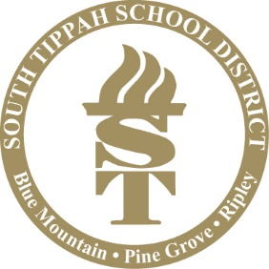

The South Tippah School District will be participating in the USDA’s National School Lunch Program “Seamless Summer Option (SSO)” for duration of the 2021-2022 school year. This program, while typically only available during the summer months, will continue to extend free meals to all students during the 2021-2022 school year. According the USDA, this option maintains the nutrition standards of the standard school meal programs – including a strong emphasis on providing fruits and vegetables, milk, whole grains and sensible calorie levels. This options also provides flexibility for schools to further customize their meal service design to fit their local needs.
Nutrition is a cornerstone of learning and the South Tippah School District is proud to participate in this program to ensure the nutritional needs of every child are fulfilled; enabling our student to attain their greatest potential.

This institution is an equal opportunity provider.
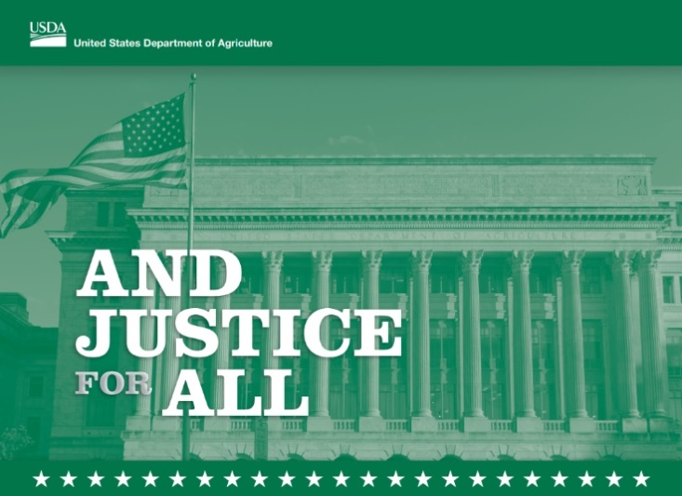
https://www.fns.usda.gov/civil-rights/usda-nondiscrimination-statement-other-fns-programs

https://www.fns.usda.gov/civil-rights/usda-nondiscrimination-statement-other-fns-programs

